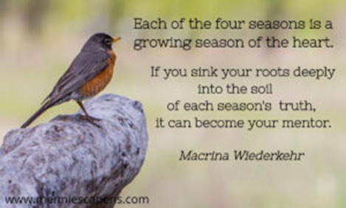

Suggested Questions for Exploring the invitation of Each Season

**Autumn/Fall** -a time of declining light, slowing down, a more gentle angle of light, planting bulbs and seeds that need cold hard ground to thrive and bloom.

-What symbolizes fall where you live?

-What seeds were planted when you were born, seeds of our true self?

-What seeds were planted in you long ago that might be starting to show?

-What seed planted in you long ago might need a bit longer before they can break through?

-What is preparing in you to be released as the leaves release for the sake of the tree’s survival?

-How might the gentler light of autumn be an invitation to see differently?

**Winter** -seeds are buried, deep below…there’s a lot happening underground, gaining nourishment from the soil. In the northern hemisphere it's a time of longer nights…a time of darkness, death, dormancy- also a time of quiet, rest, renewal, even hibernation.

-What symbolizes winter where you live?

-What invitation lies in winter’s call to slow down, quiet down, rest more?

-What in you feels dead and dormant?

-What in you might be waiting a season of renewal or rebirth?

-What is your relationship with the dark?

-Where do go to seek light?

**Spring**  - the flowering of paradox - from the frozen earth, springs forth new life. Mud, muck, humus…the mud and muck helps prepare the soil for flowering.

-What symbolizes spring where you live?

-Is there part of you that is resisting greater light, a part of you that needs a bit more time to rest and be slow?

-Is there mess in your life that might be the mess of rebirth?

-Is there beauty hidden in or emerging from the mess and chaos?

**Summer** - season of abundance and harvest and heat

-What symbolizes summer where you live?

-What is growing abundantly in my life that is meant to be harvested?

-What are you being invited to trust in this abundance?

-What does heat bring out in you?

-What invitation might rest in that heat and abundance for you?